**Test result report**

**IMAGURU**

**15.05.2023-29.06.2023**

**Test team:**

|  |  |  |
| --- | --- | --- |
| **Name** | **Position** | **Role in the project** |
| Yuliya Sidarchuk | Test engineer | * Test Plan co-creator (Risk Assessment paragraph) * Estimation for My Project module * Creation of checklists * Creation of bug reports * Testing of My Project module (including Compatibility and L10n) * Peer review of Anna Taranova * TRR for My Project module |

**Testing process description:**

*Test environment:* <https://imaguru.host/version-test>

* OS Windows 10 (64 bit);
* Samsung Galaxy S20 (screen resolution 360х800).

- Browsers:

* Desktop: Google Chrome v. 113.0.5672.127;
* Mobile: Google Chrome v. 113.0.5672.162.

*Test Levels:*

* Smoke, Critical Path, Extended Tests;
* Component, Integration, System, Acceptance testing.

*Test methods and types used:*

- Functional testing:

* Positive, Negative testing;
* Static, Dynamic testing;
* New Feature, Regression testing;
* Exploratory testing;
* Black box testing;
* Manual testing.

- Non-functional testing:

* Compatibility testing;
* GUI testing;
* Usability testing;
* Localization testing.

**Summary:**

*News*: In this sprint Chat, a new functionality, was added for testing into My Project module.

*Test status*: All testing activities for this sprint were completed in time according to the schedule.

*Test analysis*:

* 33 check lists for My Project were created among which 14 tests failed (about 42%). All tests for Chat failed (100%).
* 22 new bugs were submitted by me (16 bugs for My Project module, 2 bugs for Chat, 4 bugs for other modules of Imaguru).
* 20 bugs were submitted for My Project module in general.
* Compared to the previous sprint the number of bugs for My Project module increased significantly: from 6 to 20 bugs. It must be because a new functionality was added to My Project module - Chat. 4 bugs (20%) were submitted in Chat.

*Problems and risks*:

* Incomplete stated requirements
* Fixing of bugs submitted leaves much to be desired
* Improvement of the project team communication

*Testing plans*:

* Regression testing

**Testing timetable:**

|  |  |  |  |
| --- | --- | --- | --- |
| **Tester** | **Date** | **Description** | **Duration, h** |
| Yuliya Sidarchuk | 15.05 | Documentation study | 4 |
| 18.05 - 20.05 | Bug review | 12 |
| 20.05 - 22.05 | Roles and permission table for My Project module | 6 |
| 22.05 | Review of Roles and Permission table for Event (view+add/edit) module created by Anna Taranova | 2 |
| 24.05 - 25.05 | Test plan creation (Risks Assessment paragraph) and review | 4 |
| 25.05 | Estimation for My Project module | 3 |
| 29.05 | Check lists | 2 |
| 30.05 | Review of check lists for Event (view+add/edit) module created by Anna Taranova | 1,5 |
| 30.05 - 19.06 | Bug reporting | 24 |
| 06.06 - 08.06 | Compatibility testing | 16 |
| 10.06 - 11.06 | Localization testing | 6 |
| 20.06 - 21.06 | TRR for My Project module | 6 |

**Recommendations**: It is recommended to pay special attention to regression testing due to the increase in the number of bugs in previously implemented and tested functionality and only then proceed with new features development.

**New bugs found:**

|  |  |  |
| --- | --- | --- |
| **ID** | **Severity** | **Summary** |
| GLDST4723-1054 | Critical | Mentor/Jury can create a project after following Mentor/Jury Sign Up Link |
| GLDST4723-1000 | Critical | Participant is able to create more than one project |
| GLDST4723-6828 | Critical | Messages disappear in Chat in My Project tab |
| GLDST4723-1005 | Major | "Create a project" tab is available for the user after being deleted from the project from which the user's project was created |
| GLDST4723-1034 | Medium | Message field is not marked as obligatory when sending email to a team's member in My project |
| GLDST4723-1036 | Medium | IO cannot activate "Open position for a team" toggle in Edit section in My project |
| GLDST4723-3412 | Medium | Wrong start and final days can be selected in Hackathon Timeline in Edit event tab |
| GLDST4723-3398 | Medium | Add file link and upload files don't work after YouTube link was added when editing Content of the Event |
| GLDST4723-3397 | Medium | Redundancy of Edit icons, Submit changes and Cancel buttons in Content tab of the Event |
| GLDST4723-4079 | Medium | Empty Topics, Prizes, Deliverables, Event Recordings can be added in Edit Event tab for Hackathon |
| GLDST4723-4431 | Medium | Chat is not opened in the page where it's icon is tapped in Mobile version |
| GLDST4723-6827 | Medium | No Delete button in the Team's members section in My Project |
| GLDST4723-1003 | Medium | Status of a hackathon is "joined" after deleting the user from it and "Join event" button is available for the user simultaneously |
| GLDST4723-1049 | Minor | Cursor does not change to pointer when hovering "Roles to be filled" DDL in "Open position for a team" and "Select expertise to be filled" DDL in "Mentor's expertise needed" in My project tab |
| GLDST4723-1052 | Minor | Placeholder does not disappear when inserting cursor in "Roles to be filled" in "Open position for the team" section and in "Select expertise to be filled" in "Mentor's expertise needed" section in My project tab |
| GLDST4723-1050 | Minor | Cursor does not change to pointer when hovering over "Select expertise your team needs" DDL in "Mentor's expertise needed" in My project tab |
| GLDST4723-1053 | Minor | Placeholder does not disappear when inserting cursor in "Select expertise to be filled" in "Mentor's expertise needed" section in My project tab |
| GLDST4723-4426 | Minor | L10n: No Belarussian localization in DDLs in "Шукаем людзей у каманду" section and "Мэнтары" section in My project |
| GLDST4723-4424 | Minor | L10n: Save button is not translated in Belarussian localization in Edit event in My project |
| GLDST4723-6037 | Minor | L10n: Users' roles are not translated into Belarussian in the Profile in the left sidebar and when deleting a team's member in My project |
| GLDST4723-6035 | Minor | Delete pop-up is not fully visible in Mobile when deleting a team's member in My project |
| GLDST4723-6797 | Minor | "Submit" button stays active after clicking in "Submit your progress" section in My project |

**Check lists statistics:**

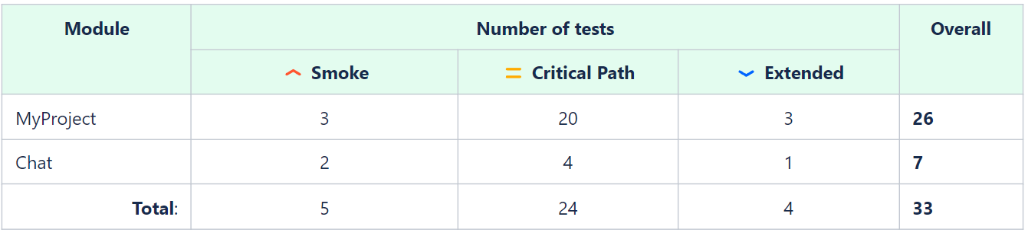

33 checklists were prepared by me for My Project module among which 14 tests failed.

**Checklist diagram for My project module:**

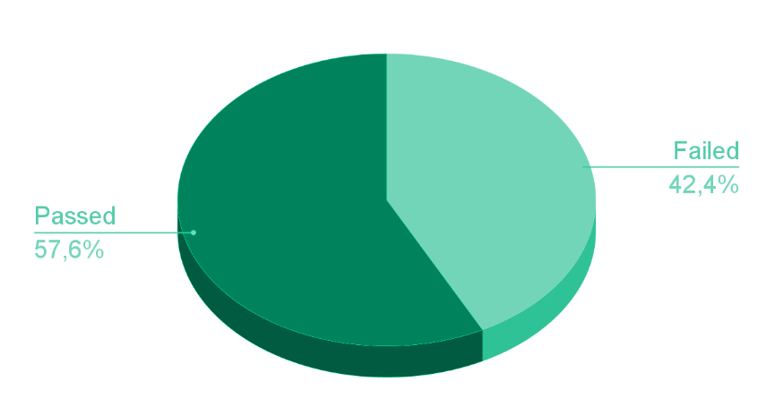

From this diagram it’s seen that about 58% of checklists for My Project passed, and about 42% failed.

**New bugs statistics:**

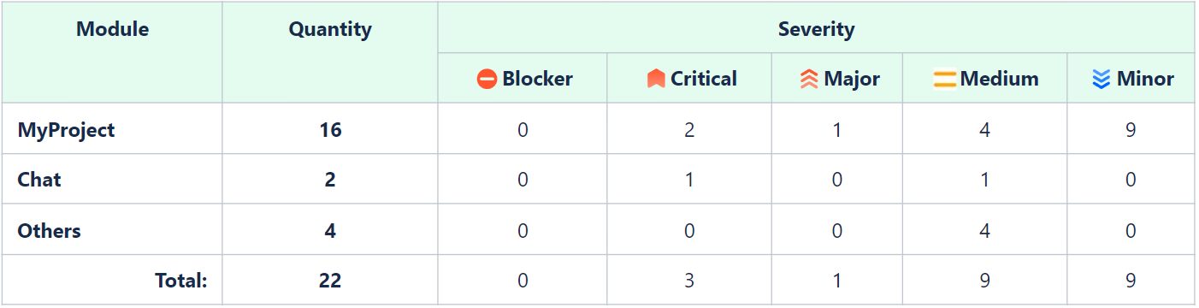

During the sprint I submitted 22 new bugs. For My Project module 16 bugs were submitted by me, 2 bugs for Chat, 4 bugs for other modules of Imaguru.

**New bugs diagram:**

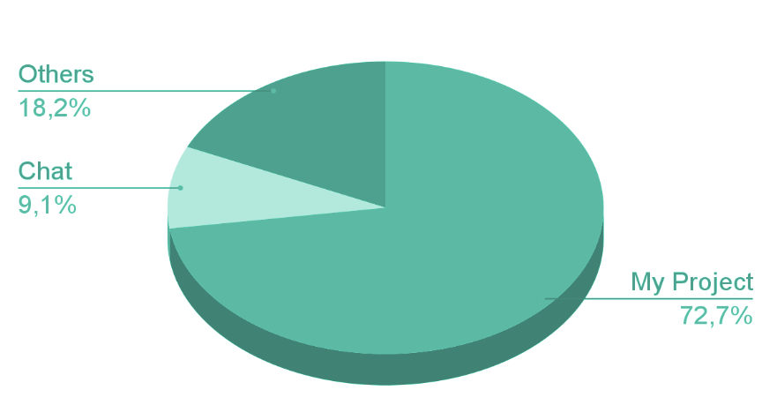

This pie chart shows new bugs percentage ratio. So, it’s about 73% for My Project, 9% for Chat and 18% for other modules.

**Comparison with previous sprints:**

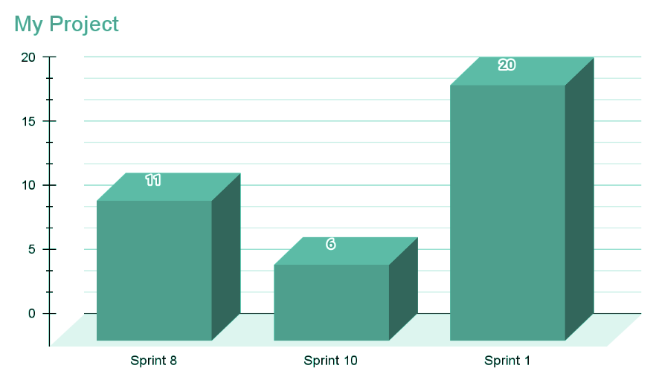

In general, our team submitted 20 bugs for My Project module in this sprint. Compared to the previous sprint the number of bugs for My Project module increased significantly, from 6 to 20 bugs. It must be because a new functionality was added in this sprint to My Project module - Chat, where 4 bugs (20%) were submitted.

**Bugs submitted vs. bugs fixed for My Project module:**

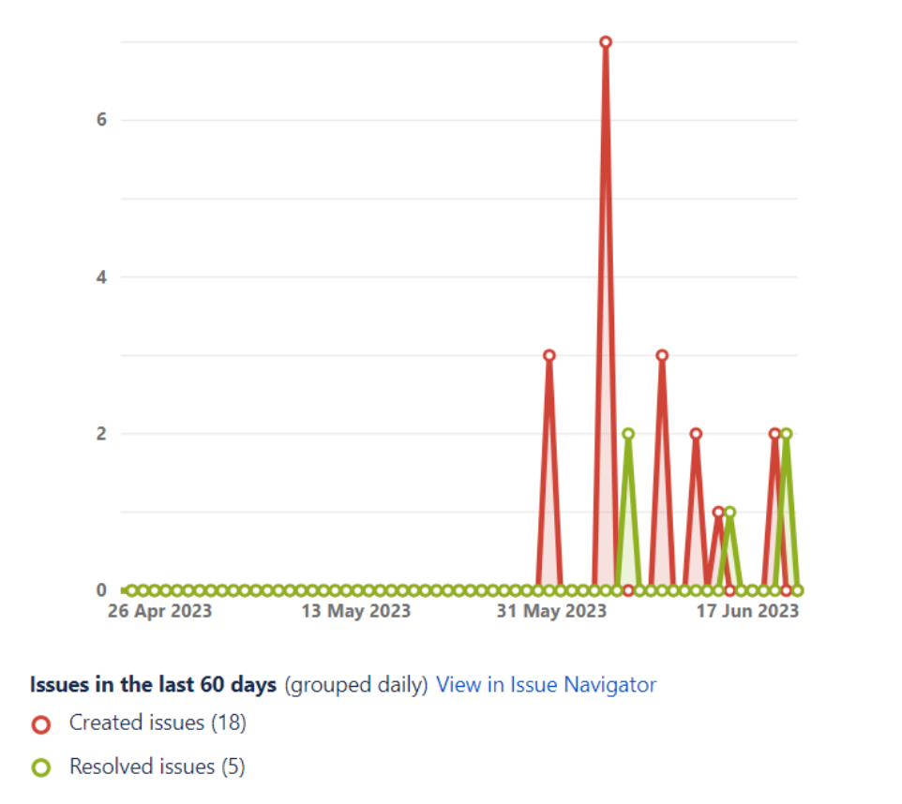

This burndown chart shows bugs submitted (red line) and bugs fixed (green line) for My Project module. The conclusion can be made that bugs with high priority/severity were fixed in the first turn.